**FORMULÁRIO DE MATRÍCULA**

**MATRÍCULA PARA O ANO DE: __________ _______ SEMESTRE**

Nome: _____________________________________________________________________________

Data de nascimento: ______/______/_____ Idade: ____________ Tel.: _________________________

Endereço: __________________________________________________________________________

Bairro: ______________________________________________________CEP: __________________

Referência: _________________________________________________________________________

Escola: _______________________________________________ Série: ______ Turno: ___________

Nome do Pai: _______________________________________________________________________

Nome da Mãe: ______________________________________________________________________

É alérgico? A quê? __________________________________________________________________

Faz uso de medicação? Qual? __________________________________________________________

Problema de saúde? Qual? ____________________________________________________________

**HORÁRIOS**

| **Horário** | **IDADE** | **TER/QUI** | **QUA/SEXT** |
| --- | --- | --- | --- |
| 9h / 9:50h | 7 aos 10 anos |  | Profª. Nayra |
| 10h / 11:50h | 11 aos 13 anos |  | Profª. Nayra |
| 14h / 14:50h | 7 aos 9 anos | Profª. Tamara |  |
| 15h / 15:50h | 10 aos 12 anos | Profª. Tamara |  |
| 16h / 16:50h | 13 aos 15 anos | Profª. Tamara |  |

Em caso de emergência ligar para: ________________________ telefone: ______________________

Responsável pelas informações: ________________________________________________________

________________________________________

ASSINATURA DO RESPONSÁVEL

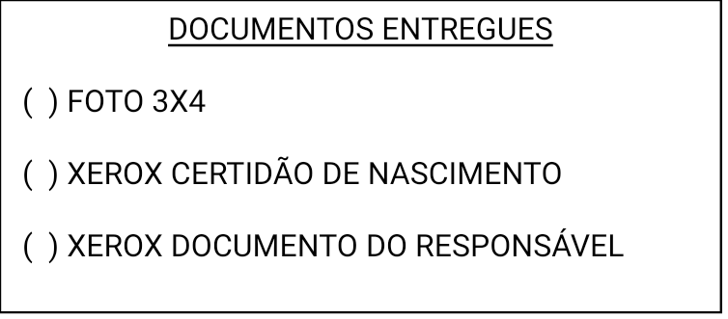

**FORMULÁRIO DE MATRÍCULA ADULTOS**

**MATRÍCULA PARA O ANO DE: __________ _______ SEMESTRE**

Nome: _____________________________________________________________________________

Servidor da UENF ( ) Discente da UENF ( )

Data de nascimento: ______/______/_____ Idade: ____________ Tel.: _________________________

Endereço: __________________________________________________________________________

Bairro: ______________________________________________________ CEP: __________________

Referência: _________________________________________________________________________

Pratica atividade física? Qual? __________________________________________________________

É alérgico? A quê? __________________________________________________________________

Faz uso de medicação? Qual? __________________________________________________________

Problema de saúde? Qual? ____________________________________________________________

**HORÁRIOS**

| **Horário** | **SEG/QUA** | **TER/QUI** | **QUA/SEXT** |
| --- | --- | --- | --- |
| 11:30h / 12:20h |  | Profª. Tamara | Profª. Nayra |
| 12:30h / 13:20h |  | Profª. Tamara | Profª. Nayra |
| 17h / 17:50h |  | Profª. Tamara |  |
| 18h / 18:50h |  | Profª. Tamara |  |
| 18:30h / 19:20h | Profª. Nayra |  |  |
| 19:30h / 20:20h | Profª. Nayra |  |  |

Em caso de emergência ligar para: ________________________ telefone: ______________________

Responsável pelas informações: ________________________________________________________

________________________________________

ASSINATURA

